Enclosure 1: Design Specification (DS)
Process Flow
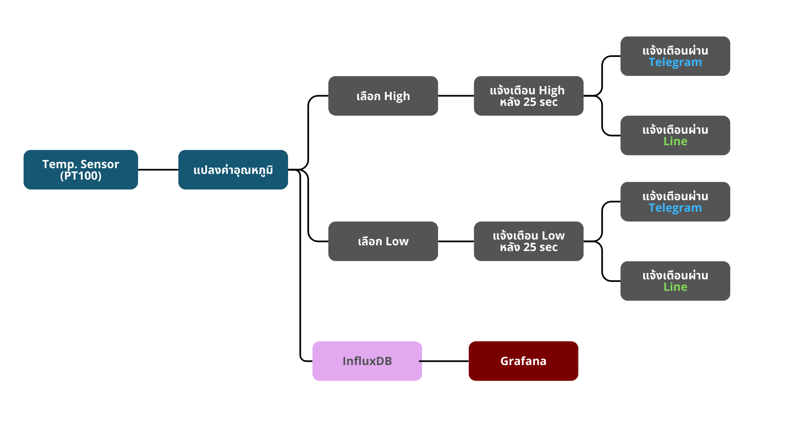
Measurement
Measurement
Alarm Management
Data Storage
Dashboard (Grafana) & Report
Alarm Management
Data storage
Dashboard (Grafana)
RS485,Modbus
Location: Grafana
Location: Node-RED
Location: Node-RED
Location: VM Server GPO/InfluxDB

